Brady Primary School

English Policy

‘Inspiring teaching for ambitious learners’

Policy Created- January 2019

To be reviewed as required

Aims of Brady Primary School

“Inspiring teaching, for ambitious learners”

At Brady Primary School our ethos is built around our 4 core values of Dedication, Inspiration, Respect and Achievement. These help us to provide a safe, caring and stimulating environment, which offers opportunities:-

- For everyone within the school to reach their full potential and develop self-worth, self-confidence, the ability to take responsibility for their own individual actions, and resilience.
- For everyone within the school to have a sense of wonder, an enthusiasm for learning and help children to develop as independent thinkers and learners with enquiring minds.
- To encourage and develop a respect and understanding for others.
- To develop all partnerships, small and large, from the individual parent to the wider community and beyond to support children’s learning.
- To give children access to a broad and balanced creative curriculum to attain the highest possible standards in relation to prior attainment through assessment, teaching and learning.

Equal opportunities and Inclusion

At Brady Primary School we believe that every child is entitled to equal access to the curriculum, regardless of race, gender, class or disability. We are committed to promoting learning and teaching environments, for all that embed the values of inclusive educational practices. Through a child-centered approach, we aim to ensure that education is accessible and relevant to all our learners, to respect each other and to celebrate diversity and difference.

Contents of this Policy
- Spoken language
- Writing
- Assessment and Staff Development

Spoken language

The national curriculum for English reflects the importance of spoken language in pupils’ development across the whole curriculum – cognitively, socially and linguistically. Spoken language underpins the development of reading and writing. The quality and variety of language that pupils hear and speak are vital for developing their vocabulary and grammar and their understanding for reading and writing. We expect staff to model the English language accurately and place an emphasis on staff using planned-for vocabulary to extend the children’s expressive language.

At Brady, we ensure the continual development of pupils’ confidence and competence in spoken language and listening skills. We recognize that often on-entry to Reception many children are working behind ARE and we model effective language, storytelling, questioning and conversation to ensure all children make progress. Children take a Language Link assessment in Reception to enable staff to quickly identify specific areas of need, e.g. understanding instructions, tenses, prepositions etc.

Throughout the school, children are actively required to participate in orally rehearsing their ideas, participate in discussions and debates and to justify their opinions. Pupils have opportunities to improvise, devise and script drama for one another and a range of audiences, as well as to rehearse, refine, share and respond thoughtfully to drama and theatre performances.

Teachers should ensure the continual development of pupils’ confidence and competence in spoken language and listening skills. Pupils should develop a capacity to explain their understanding of books and other reading, and to prepare their ideas before they write. They must be assisted in making their thinking clear to themselves as well as to others, and teachers should ensure that pupils build secure foundations by using discussion to probe and remedy their misconceptions.

Statutory requirements which underpin all aspects of spoken language across the six years of primary education form part of the national curriculum. These are reflected and contextualised within writing which follows.

Writing

The programs of study for writing at Key stages 1 and 2 are:

- transcription (spelling and handwriting)
- composition (articulating ideas and structuring them in speech and writing)

At Brady we develop pupils’ competence in both dimensions through rich, well planned literacy lessons. Pupils have access to a wide range of writing opportunities which include: shared writing, guided writing, extended writing, collaborative and independent writing. Children experience writing different styles for example, reports, narratives, poetry, information passages, instructions, recounts and play scripts. Not all writing is expected to be pages long across lines and lines. We value all writing and encourage children to write for a variety of purposes using a range of media – from large paper, to strips, post-its, letters, annotated illustrations – everything is part of our pupils learning. We endeavor to provide opportunities for children to have time for extended writing, following lessons that have taught skills and fed ideas to ensure pupils are confident to have a go.

The Writing Journey
Teachers plan from Literacy Shed, Cornerstones and their own love of literacy. English lessons range from being related to their shared reading text to being cross curricular in nature. Teachers in Key Stage 2 use the following sequence in English lessons to ensure new grammar skills are taught purposefully, and embedded within a writing genre. The aim by the end of the year is that Year 2 children are confidently following this writing journey also.

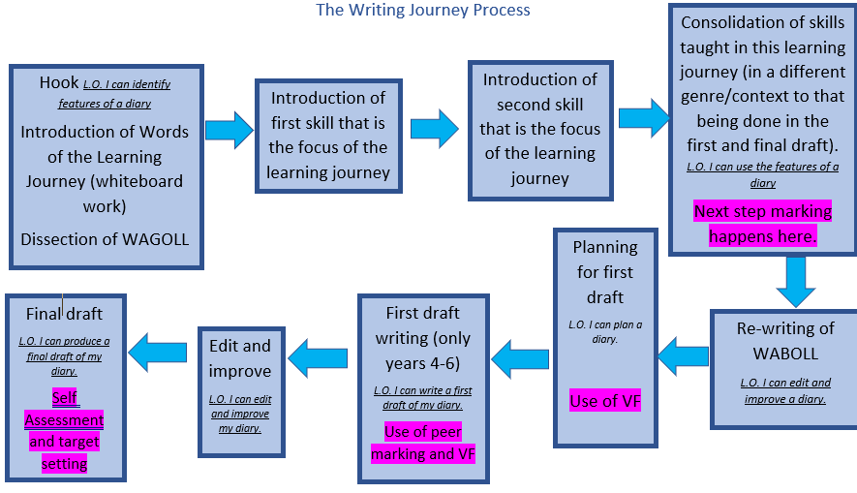

Spellings
Children are expected to learn spellings from the National Curriculum each week. These are tested and monitored by staff so that children who need additional practice can work with a member of support staff if it is required. Spellings form part of effective transcription and we believe encouraging children to spell accurately improves their confidence as a writer. We provide dictionaries and teach children about spelling patterns and structures so that they are able to make good attempts at unknown or unfamiliar words. At the very least we would encourage our developing writers to make phonetically plausible attempts to communicate their ideas on paper. Spelling Shed is used in Key Stage 2 to set spellings, and Friday morning lessons are reserved to embed the new spelling rule each week. In Reception to Year 2, spellings are related to words that are phonetically decodable, as well as the ‘red’ (common exception words) relevant to their stage of RWInc Get Writing.

Handwriting
It is paramount that children are taught the correct letter formation from the beginning of their time at school. Children should be taught to sit correctly in order to have the correct posture for writing, hold a pencil with the correct grip and develop a fluent, legible style. Children are taught in Reception and Year 1 to form letters correctly. Cursive, joined handwriting, is introduced and embedded when appropriate in Year 2, so that all handwriting modelled in Year 2 upwards is joined up. It is expected that all staff follow the handwriting policy document and model this at all times. Children are encouraged to join letters correctly from Year 2. By the end of Key Stage 2, all children should be displaying an efficient, quick, neat and legible handwriting style that is effective in recording their ideas.

Staff development

Teachers are expected to keep up to date with subject knowledge and use current materials that are available in school or online. Training needs are identified as a result of whole school monitoring and evaluation, performance management and through induction programmes. The English co-ordinator will arrange for relevant advice and information, such as feedback from courses or newsletters, to be disseminated. Additional adults who are involved with intervention programmes will receive appropriate training that may be school based or part of central training.

Assessment, Recording and Reporting

Teachers use effective assessment for learning to ensure planning is based on prior attainment and that pupils know what they have to do to achieve the next steps. Individual targets after independent writing in Years 2-6. Marking must follow the school marking policy which provides pupils with clear feedback and next steps. Children are given time to edit and improve their writing as part of the writing journey.

Parents are informed of their child’s progress at termly meetings and a report showing results in reading and writing is completed at the end of the year. Individual concerns are discussed at meetings which parents can arrange with the class teacher at any point throughout the year.

