Catch-Up Premium Plan
Brady Primary School

Summary Information
School |  | Brady Primary School
Academic Year | 2020-2021/ 2022 | Total Catch-up funding | £16,560 | Number of pupils on roll | 272

Guidance
Children and young people across the country have experienced unprecedented disruption to their education as a result of the coronavirus (COVID19). Those from the most vulnerable and disadvantaged backgrounds will be among those hardest hit. The aggregate impact of lost time in education will be substantial, and the scale of our response must match he scale of the challenge.

School’s allocations will be calculated on a per pupil basis, providing each mainstream school with a total of £80 for each pupil in years Reception through to 11.

As the catch-up premium has been designed to mitigate the effects of the unique disruption caused by coronavirus (COVID19), the grant will only be available currently for the 2020-2021 academic year, however this is under review. It cannot be added to schools’ baselines in calculating future years’ funding allocations.

Use of funds | EEF Recommendations
Schools should use this funding for specific activities or resources to support their pupils to catch up for lost teaching over the previous year in line with the guidance on curriculum expectations for the current academic year.  Schools have the flexibility to spend their funding in the best way for their cohort and circumstances.  To support schools to make the best use of this funding, the Education Endowment Foundation (EEF) has published a Coronavirus support guide for schools with evidence-based approaches to aid cat-up for all students. Schools should use this document to help the, direct their additional funding in the most effective way. | The EEF advises the following:  Teaching and whole school strategies  - Supporting great teaching  - Pupil assessment and feedback  - Transition support  Targeted approaches  - One to one and small group tuition  - Intervention programmes  Wider strategies  - Supporting parents and carers  - Access to technology

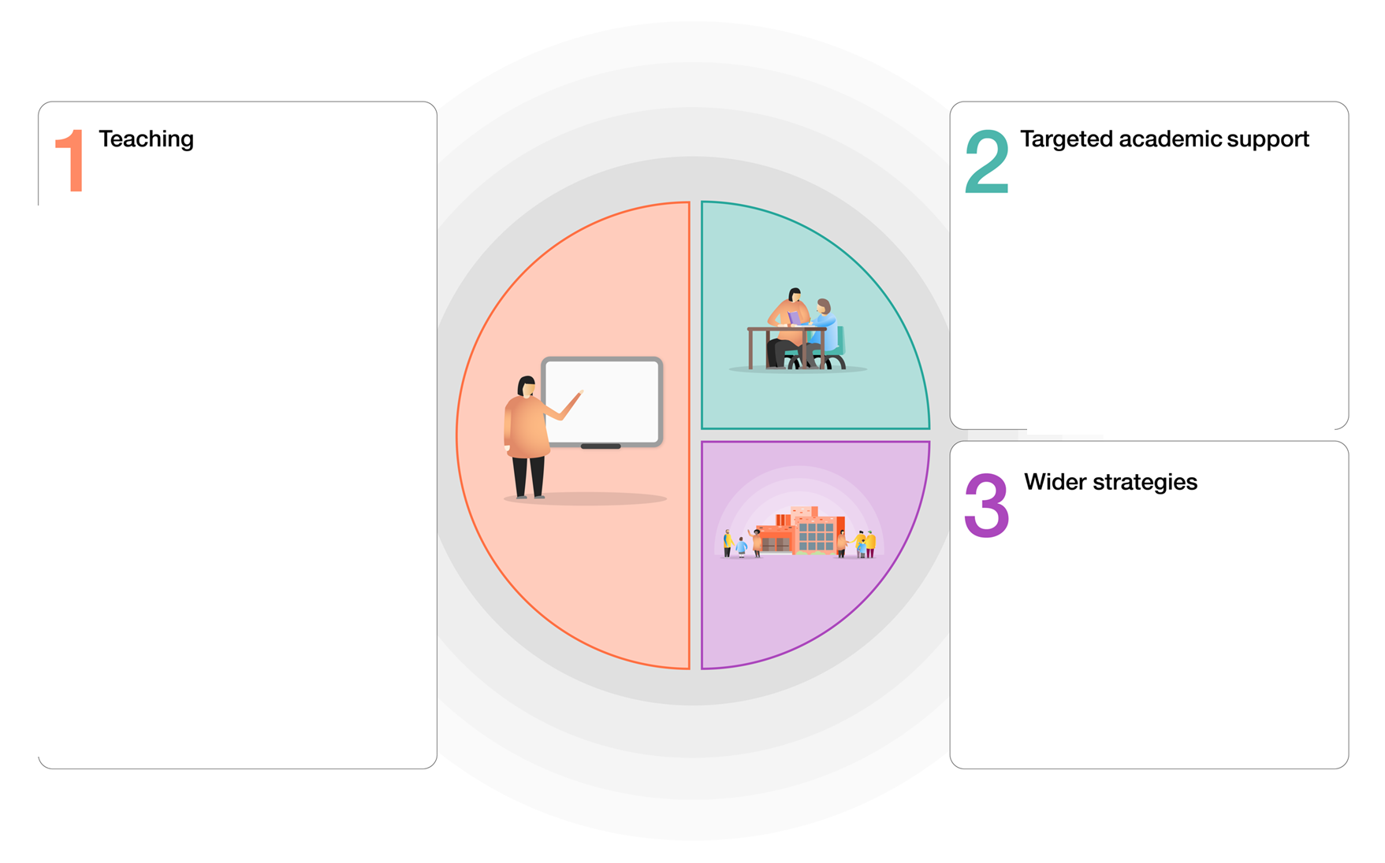
Specialist teachers enhancing the curriculum
Workshops to enhance curriculum and build cultural capital
Pastoral support/ counselling
Staff wellbeing focus
1 Decision PSHE lessons
Additional teacher led support in Year 6
Pupil progress meetings each half term
Pastoral support provides 1:1 support to assist children where needed
Targeted support and deployment of Tas
Targeted use of Seesaw to plug gaps in learning through homework
Quality first teaching supported by evidence informed CPD for teachers and support staff
A broad and engaging curriculum that focuses on vocabulary acquisition
Knowledge and skills rich curriculum with teachers building on previous learning
Whole class Guided Reading sessions and Oxford Owl
Focus on key essentials for Reading, Writing and Maths- online learning packages to support at home if required eg (TT Rockstars, Oxford Owl and Numbots)
Regular staff CPD on mental health and well being
Provide a suite of Home Learning activities for children required to be at home through Seesaw
EYFS focus on oracy and early language development

Identified impact of lockdown
The following has been identified through teacher consultations, baseline assessments, Target Data and blended learning submitted through the most recent lockdown
Maths | Specific content has been missed, leading to gaps in learning and stalled sequencing of the progression of skills. Children still enjoy maths and lockdown has not affected their attitude, however, they are simply not at the points we would hope for them to be currently. This has been identified in our Reintroduction Baseline Assessments. Recall of basic skills have suffered- some children are not able to recall addition facts, times tables and have forgotten calculation strategies that were clear before the National lockdown. This was reflected in the arithmetic assessments. Many children accessed a large percentage of the home learning maths available through Seesaw, but this is not the same as quality first teaching in the classroom.
Writing | Children have not missed whole units of writing in the same way they have in maths, however they have lost essential practising of writing skills. GPS specific knowledge has dropped, leading to a lack of fluency in writing. Writing stamina on the whole has also been affected. Those who have maintained their writing through lockdown have been less affected, however those who did not write much while at home have had to work additionally hard to try and regain the level they were at prior to lockdown. Some children have also showed a lack of motivation for writing since lockdown, this is not helped by a lack of fluency which makes it harder for them to complete.
Reading | Children’s reading during lockdown seems to be the least affected, children had access to good quality Guided Reading sessions as well as digital books through Oxford Owl. That being said, children are now less fluent than they were before and the gap between those who read widely at home and those who do not is now bigger than before.
Non-core | There are now significant gaps in knowledge through topics that simply could not be taught whilst the children were at home. Whole units of work have been missed in all year groups and this will need to be addressed as the children move through the school. This means that a lot of the existing knowledge that children would have had when starting a topic, is missing and therefore the children may struggle to make connections within their learning. The children have also missed out on a vast amount of cultural capital and curriculum experience, including; trips, school visitors and wow curriculum moments.

Planned expenditure
1, Teaching and whole- school strategies
Desired outcome | Chosen approach and anticipated cost | Impact (once reviewed) | Staff lead | Review date
Teaching assessment and feedback:  Teachers have a very clear understanding of what gaps in learning remain and use this to inform assessments of learning that are aligned with standardised norms, giving a greater degree of confidence and accuracy to assessments | To use the bank of year group specific assessments already in place for the periodic assessment of the children. (baseline assessments to be completed with the previous end of year test).  Complete termly sets of data on Target tracker using all available graphs to analyse this data.  To complete a pupil progress meeting at the end of each term.  (£0 cost from Catch up budget) |  | MN/ RL | Termly
Total budgeted cost from catch up budget |  |  |  | £0
2, Targeted approaches
Desired outcome | Chosen approach and anticipated cost | Impact (once reviewed) | Staff lead | Review date
1 to 1 and small group tuition:  To ensure that children who are registered as Pupil Premium or EAL have the opportunity to work with an intervention member of staff to try and aid the process of closing the gaps between them and their peers. | A member of staff will be selected as an intervention lead teacher for PP and EAL working across all afternoons of the week.  These children will be selected through data and discussions with SLT and the class teacher at pupil progress meetings half termly.  (£5,000 cost from Catch up budget) |  | MN/ CZ
Access to support materials:  To ensure that the children have access to good quality learning materials both at home and at school to try and close the gaps created by long periods of lockdown out of school. These resources will be used how the teacher deems most effective for each class based on their individual and collective needs. | All children across KS2 in 2021-22 will receive a CGP bundle pack to support their learning both at home and in school.  (£ 1,320 cost from Catch up budget)  All children in EYFS and KS1 will have the advantage of extra phonics resources. This will be lead by the EYFS and Phonics leads. |  | MN/ RL/ AD
Total budgeted cost from catch up budget |  |  |  | £6,320
3, Wider strategies
Desired outcome | Chosen approach and anticipated cost | Impact (once reviewed) | Staff lead | Review date
Supporting parents and carers:  Children will have greater opportunities to access learning at home. Home-learning opportunities will not always require parents to engage with the activities, affording the children greater independence and increasing the likelihood that parents can sustain home-learning if required to isolate.  Children have access to appropriate stationery and paper-based home-learning if required so that all can access learning irrespective of ability of child/parent to navigate the online learning.  Pupils eligible for FSM will not be disadvantaged if self-isolating and will still be provided with meals. | We will continue to use Seesaw to engage with parents and carers at home and also to provide remote home learning when pupils isolate.  (£0 cost from Catch up budget)  Home-learning paper packs are printed and ready to distribute for all children. Stationery packs are to be purchased and set aside for children to take home when home-learning occurs.  (£0 cost from Catch up budget)  Vulnerable families will continue to have access to the school voucher system should isolation be needed.  (£0 cost from Catch up budget) |  | SLT
Access to technology:  To ensure that children have access to high quality computing equipment in order to continue using the online packages that we subscribe to for both intervention and whole class time.  Children can access additional devices so they can rotate through discrete teaching, reading fluency and independent online activities. | New bank of school Ipads (15) purchased and used on a rota across the school.  (£7,000 cost from Catch up budget)  Computers that were donated to the school to be turned into a new 15 station computing suite.  (£200 cost from Catch up budget)  School’s DFE devices given to pupils isolating(where required) so remote learning can take place via the Seesaw app.  (£0 cost from Catch up budget) |  | MN/ JS
Mental Health and Wellbeing support:  To ensure that children are in the right state of mind to ensure that they can learn. Interventions completed by a trained member of staff to ensure children feel comfortable in school | School to train a new ELSA  (£200 cost from Catch up budget)  Member of staff trained in Lego Therapy  (£0 cost from Catch up budget)  Member of staff used to take out small groups two mornings a week. These children will be selected through data and discussions with SLT and the class teacher at pupil progress meetings half termly.  (£2,000 cost from Catch up budget) |  | MN/ CZ
Total budgeted cost from catch up budget |  |  |  | £9,400
Total cost |  |  |  | £15,720
Costs paid through Covid catch up budget
Costs paid through school budget

