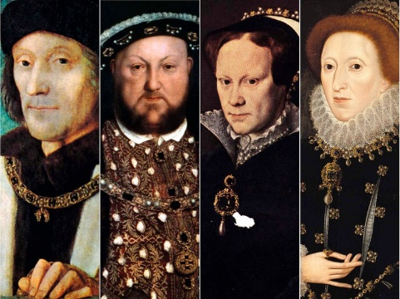

Year 5 - Spring 1 Off with her head

**History**

* Use a range of sources to research the House of Tudor and the five Tudor monarchs. Record your findings by writing a list of facts. Then, write a short paragraph about Henry VII, Henry VIII, Edward VI, Mary I and Elizabeth I.
* Find out why Thomas Cromwell, Francis Drake and Anne Boleyn were key figures during Tudor times. Record your findings in a table to explain their role and importance.
* Use a range of sources to find out about key events from the House of Tudor’s rule. Create a timeline to record the events and dates on which they happened. Include a few sentences on your timeline to explain each event.
* Portraits of monarchs give messages about their power, status and personality and do not always show what the monarch looked like in real life. Look online at a range of portraits, then create a portrait of a Tudor monarch or other important Tudor figure. Think about how you can show their power, status or personality, using colour, expression, poses, clothing, and background objects or setting.
* Listen to a range of courtly Tudor music. Identify the instruments that you can hear and describe how the music makes you feel.
* Research Tudor costumes and jewellery and make detailed observations and sketches

**English**

* Create a project glossary by writing a definition for each of the words listed. Use a dictionary to help. Add any other terms that you learn while completing the other home learning activities.

•annulment •behead •succession •treason •dynasty •excommunicate •trial

* Choose an important event from Tudor times and write a newspaper report about it. Imagine that you are reporting about the event after it happened. Examples of events include Anne Boleyn’s beheading, Henry VIII’s marriages,

Edward VI’s birth or Elizabeth I’s death. Include a snappy headline, byline, date, orientation paragraph and relevant facts.

* Finish your home learning by writing a summary of the topic, explaining what you have learned about Tudor times, Tudor monarchs and other key figures.