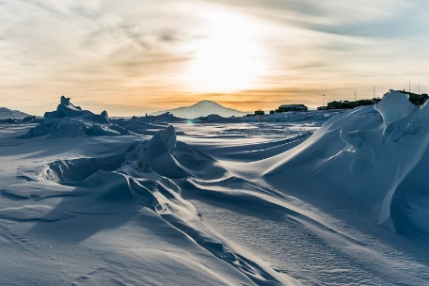

**P.E**

* P.E will continue to be on a **THURSDAY**

**Maths**

We will be revising our use of fractions this term and will be:

* Simplifying and identifying equivalent fractions
* Converting improper fractions to mixed numbers
* Comparing and ordering fractions with different denominators
* Adding and subtracting fractions and mixed numbers
* Multiplying fractions
* Dividing fractions by whole numbers
* Finding fractions of amounts

Towards the end of this half term we will be revising our measurement knowledge.

**Topic**

* In DT we will be learning about remarkable engineers and significant bridges, before we take on the challenge to create a bridge prototype.
* In Science we will be looking at how living things are classified including micro-organisms.
* In Geography we will be studying the Arctic and Antarctic and looking at the vegetation and human features of the area.
* In History we will be learning about the story of the Titanic and finding out what life was like on board.
* In computing we will be using a range of programs to research and present information for a given audience.

**Literacy**

This term we will be looking at a range of non – fiction texts and will be using these texts to develop our own non – fiction writing.

* Non-chronological reports
* Newspaper reports

Towards the end of term we will be writing poetry.

For reading we will be looking at recounts and will be using the features of non-fiction texts.

**Frozen Kingdom**