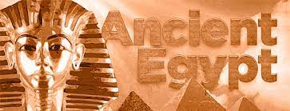

**PE**

This term our PE lesson will be on a Wednesday morning. Please ensure your children come to school wearing their PE kit.

**Topic**

This term our topic will be Ancient Egypt.

In History we will be learning about the significant events in the Ancient Egyptian era and will be placing these on a time line. We will also be looking at the beliefs of the Ancient Egyptians including their gods and what they believed would happen to them in the afterlife!

In Art, we will be using a range of resources to make our own canopic jars.

**Maths**

In Maths, we will begin by revising our understanding of place value including Roman numerals. We will be reading and writing numbers up to one million and will be comparing and ordering numbers. We will also practise rounding numbers up to one million.

After, we will practise our mental strategies for addition and subtraction and will be revising our formal written methods also.

We will finish the half term by revising our understanding of factors, multiples and squared numbers.

**English**

For English this term we will be looking at the features of a newspaper report and completing out own report based on our class text. We will also be revising our use of different clauses and punctuation. We will also be looking at non-chronological reports and will be creating our own on Ancient Egypt.

Spellings will be on a Monday and reading records will be collected in on a Wednesday.