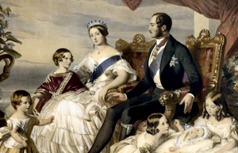

**Revolution**

**Topic**

* In History we will be learning about the Victorians, we will be learning about who they were and what life was like in the Victorian slums. We will be looking at crimes and punishments during the Victorian era and about the significant inventions that were made during this time.
* In Art we will be looking at different Victorian paintings and re-creating our own versions.
* In Computing we will be using a range of programs to research information.

**P.E**

* This term P.E will be on a **THURSDAY.**

Please ensure you come to school in your PE kit.

**Maths**

This term we will be:

* Revising the place value of numbers to 10 million.
* Ordering and comparing numbers including decimals.
* Using negative numbers and calculating intervals crossing zero.
* Using formal written methods for addition, subtraction, multiplication and division.
* Rounding numbers to the required degree.
* Continuing to practise our times tables.

**Literacy**

This term we will be looking at the settings and characters found in our class text (Street Child). We will be looking at how to use a range of figurative language to describe them. Towards the end of the term, we will be writing an alternative ending to our text. We will also be looking at the features of persuasive writing.