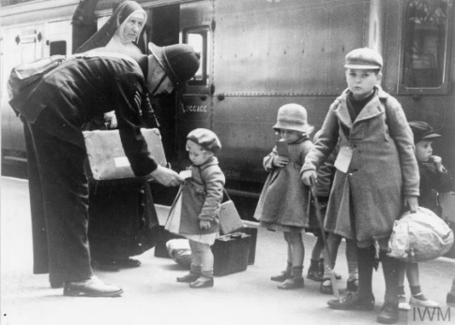

**Science**

* For Science this term we will be learning about the heart and blood. We will be learning about the composition of blood and how it travels through our body as well as how the heart beats to pump blood around the body
* We will look at how a healthy / unhealthy lifestyle can impact our heart health

**English**

* This term in English we will be writing poems and a biography. We will be developing key skills by including a variety of punctuation to show clarity.
* In Reading, we will be looking at poem “The Lady of Shalott” and we will be using this poem to complete a range of activities. We will be answering our VIPERS questions based on this text

**Maths**

When learning about Fractions, Decimals and Percentages we will be:

* Finding equivalent fractions, decimals and percentages
* Ordering fractions, decimals and percentages
* Finding a percentage of an amount

When learning about area, perimeter and volume we will be:

* Recapping finding area and perimeter
* Finding areas of triangles
* Finding volume of cuboids

When learning about statistics we will be:

* Pulling information from line, bar and pie charts
* Finding the mean

**History**

In History this term, we will be continuing our work on Britain during World War Two. We will be looking into significant events such as the battle of Britain and significant individuals such as Anne Frank. We will also be looking at post war Britain and how we remember these important events today.

**Britain at War (2)**