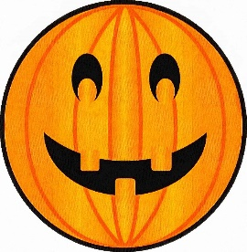­­

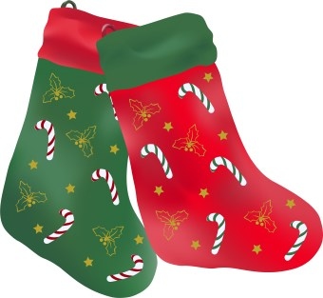

[This Photo](https://www.dailyclipart.net/clipart/christmas-stocking-clip-art/) by Unknown Author is licensed under [CC BY-ND](https://creativecommons.org/licenses/by-nd/3.0/)

Tell us something that makes you super proud of your child this half term







What has been your child’s favourite learning this half term? Please refer to our lovely school website to jog their memories!

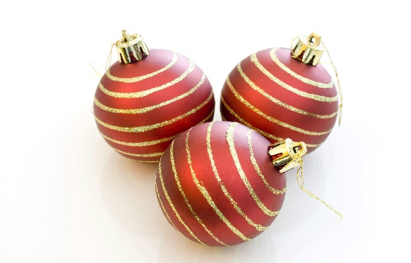

[This Photo](https://christmasstockimages.com/free/objects/slides/three_baubles.htm) by Unknown Author is licensed under [CC BY](https://creativecommons.org/licenses/by/3.0/)

Please return your proud clouds by Friday 4th November 2022. 😊

