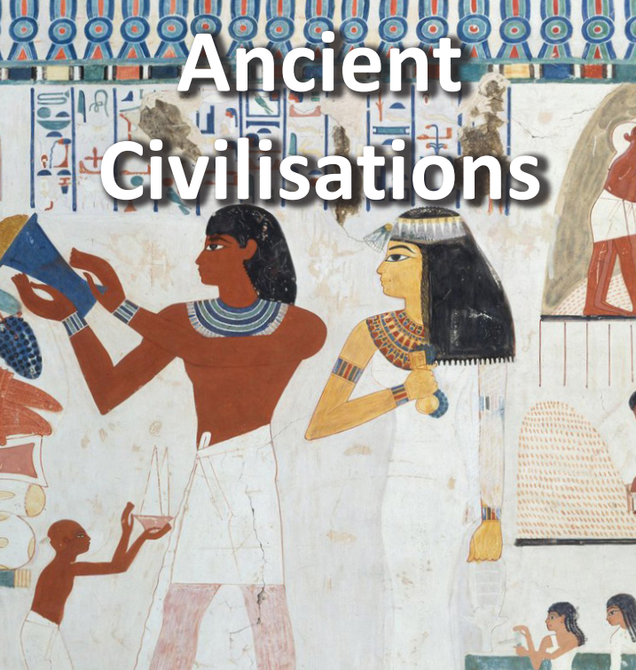

**Geography/History**

* The ancient Egyptian hierarchy had the pharaoh at the top followed by the vizier, priests, scribes and soldiers, craftspeople and merchants, peasant farmers and slaves. Create a hierarchy table.
* Research about the Sumerian city and create a poster using the information you have found.

**Art and Design**

* Create your own Egyptian tomb or coffin for a mummy.
* Create your own Egyptian pyramid; this can be done using cardboard/plastic bottles.
* Using an old white mug/bowl create your own Egyptian style design.

**Literacy**

* Create a free verse poem inspired by one of the Sumerian Temple Hymns. Choose one temple and its god or goddess as the subject of the poem.
* Write instructions text about how to make an Egyptian mummy. Use fronted adverbials/ bullet points and numbers. Use YouTube/ google to help find resources.
* Create a fact file about Sargon the great.

**Maths**

* Keep practicing your multiplication and division facts for each times-table (up to 12s).