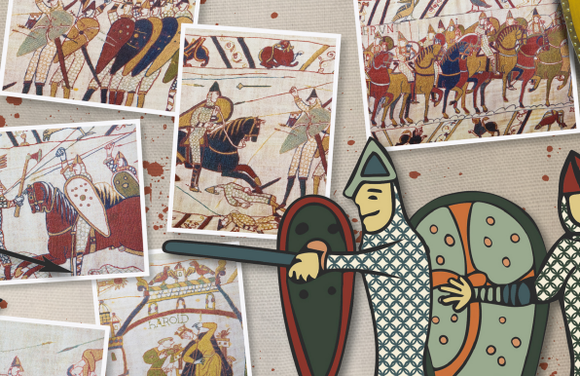

**History**

* The Bayeux tapestry tells the story of the Norman Conquest. Use online sources to find out more about this amazing artefact. Answer the questions and record any interesting facts that you discover, then choose a section of the tapestry that you find interesting and draw a picture of it.
* Everyday life for the Anglo-Saxons changed after the Norman invasion. Use a range of sources to find out about Norman society and the changes that happened after the invasion. Complete a fact hunt and record your findings under headings, such as the feudal system, the Doomsday Book and taxes, religion, art, entertainment, homes, clothes, country life or becoming a knight, to organise your facts.

**Literacy**

* Use information books and online sources to help you answer the enquiry question ‘Who were the Normans and what was the Norman Conquest of England?’ Write a few paragraphs to answer the question.
* Use a range of sources to find out about the Battle of Hastings. Create a mind map to record your findings under headings of your choice. Then, use your mind map to write a report about the Battle of Hastings, including what happened after the battle. Include a title, opening paragraph, headings, facts and at least one picture with a caption.
* Find out about the historical figures listed and their importance to the story of the Norman Conquest of England. Write a paragraph about each figure. Include details about when each figure lived, who they were and how they were involved in the Norman Conquest. • Edward the Confessor • Harold II, also called Harold Godwinson • Harald Hardrada • William the Conqueror, also called William, Duke of Normandy

**Maths**

* Keep practicing your multiplication and division facts for each times-table (up to 12s).
* Practice using column method for both addition and subtraction, challenge yourself with 3 and 4-digit numbers.

**Art and Design**

* The Bayeux tapestry tells the story of the Norman Conquest. Use online sources to find out more about this amazing artefact. Answer the questions and record any interesting facts that you discover, then choose a section of the tapestry that you find interesting and draw a picture of it.

1066