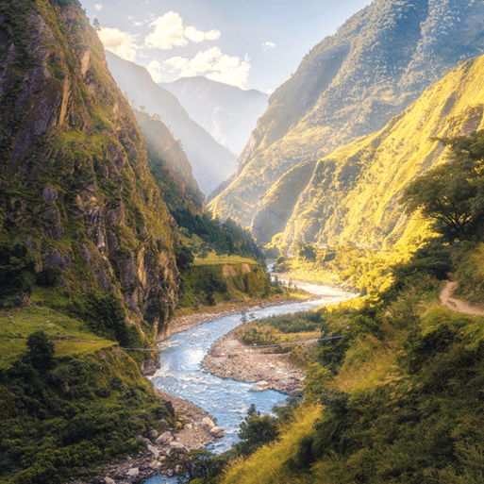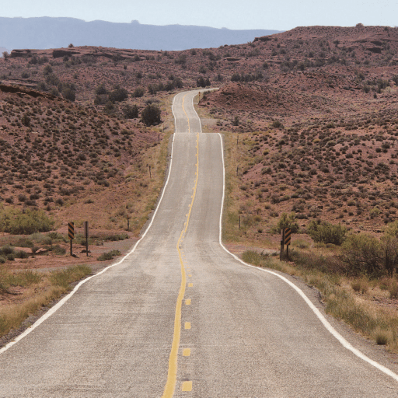

**PE**

* This term, PE will be on a Friday afternoon. Please ensure that children still come into school wearing their PE kit.

**Maths**

Throughout this term, we will be:

* Continuing with our topic on decimals, focussing on making a whole with tenths and hundredths, partitioning decimals, comparing decimals, ordering decimals and rounding to the nearest whole number.
* Our next topic will be money and then time.
* At the end of the term, we will be consolidating what we have learnt so far through these topics.
* Every week we will be completing our times table tests, with the children aiming to pass at least one level every half term.

Misty Mountain, Winding River

**Literacy**

* This term, we are reading the secrets of the sun king. During our reading lessons, we will be persevering with developing our skills in defining vocabulary, inference, making predictions, retrieval and summarising/sequencing events.
* In English, in our first unit the children will be practicing their setting description writing skill. We will then be working on writing an informal letter.

**Topic**

* In Geography, we will continue looking at rivers and mountains, focussing especially on mountains this half-term. This will include how they are formed, and famous mountains in the world and in the UK.
* In Art this term, we are looking at landscapes and atmospheric images. By the end of the topic, children will aim to become landscape artists, painting or drawing a mountainous landscape of their choice.
* In Science, our topic is living things and their habitat. The children will be exploring different animals, classification, environmental changes.
* For our DT lesson, we are going to start our tomb builder’s topic, which will be linked, with our ancient civilisation topic next term.
* The children will continue to learn French weekly, with our topic this term being ‘Animals’, as well as weekly Computing, Music and PSHE lessons.