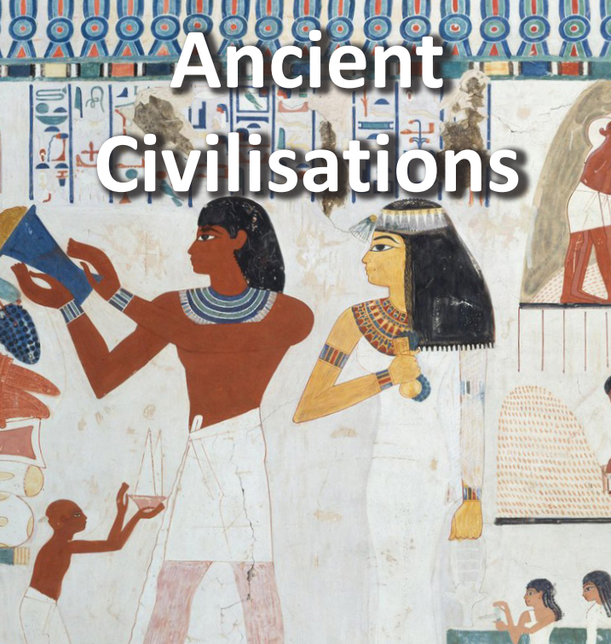

**Key dates:**

Friday 13th June – FOB father’s day sale

Tuesday 17th June- 4P class assembly 1:30- 1:45 & Shared learning 1:45- 2:45

Friday 20th June- Sports day

Monday 23rd – Friday 27th June – assessment week

Wednesday 16th July – Meet the teacher day

**History**

Ancient civilisations topic will teach us the history of the three of the world’s first ancient civilisations: ancient summer, ancient Egypt and the Indus Valley civilisation. Children will learn about the rise, life, achievements and eventual end of each civilisation.

**English & Shared reading.**

This half term we will be looking at how to write a narrative, biography and a balanced argument

We are reading ‘secrets of a sun king’, which is linked with our ancient civilisations topic.

**Maths**

We will be learning the topics on shapes, statistics and position and direction. As well as continuing to practice our timetables.

Art & R.E

In DT we will be starting a new topic called ‘tomb builders’. This topic is linked with ancient civilisations. We will learn about simple machines, including wheels, axles, inclined planes, pulleys and levers, exploring how they helped ancient builders to lift and move heavy loads.

In R.E we will be discussing how and why believers show their commitments through the journey of lines in different religions.