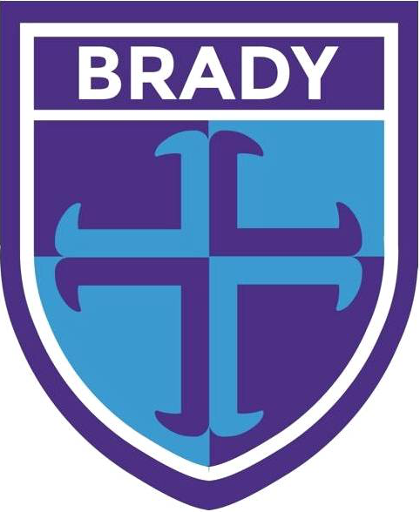
Year 1 Newsletter

Childhood Topic
Our topic this term will be ‘Childhood’ which will incorporate English, Science, Computing and Art and DT.

English
Our focus stories will include Wilfrid Gordon McDonald Partridge and Lost in the Toy Museum. The children’s writing will be based around these focus stories. They will continue to consolidate their learning by applying their phonic knowledge, using conjunctions and including learnt punctuation. The children will also be learning about singular and plural words and prefixes.

The children will have daily phonics sessions to develop their decoding skills for reading and they will continue to visit the library weekly to change their library book.

Maths
This half term the children will be learning about the properties of shapes and they will continue to focus on addition and subtraction (within 20), then place value (within 50).

Homework
Homework for the half term will be issued at the beginning of each half term and children can complete a range of tasks based on the homework map. This can now be found on the school website. Please ensure you have signed up in order to access this.

We expect children to read their allocated phonics’ reading book fluently before it is changed. They will only be changed if they are able to do this.

Please ensure that your child is using Numbots. We would like to see children logging on weekly to support their number bond knowledge. If you have any issues with your login, please speak to your child’s class teacher.

P.E.
This term P.E. will continue to be on a Thursday afternoon. Please ensure children avoid wearing any jewellery on this day.

Correct Kit consists of:
Blue Brady logo T-shirt
Navy shorts
Black plimsolls or trainers (no high tops)
Black or grey or white socks
A plain blue, black or grey tracksuit – with no large logos or slogans.

How can you help?
Listening and asking your child questions about their reading is the best support you can give your child during their school year. Children are expected to read 4-5 times a week which will help to ensure they meet the threshold for reading rewards.

At the back of each phonics’ book, you will find some useful questions and prompts to ask your child about what they have read. If you can take a few moments to discuss the text, this will help your child to develop their comprehension skills.

Regularly practising number bonds to 20 and counting one more and less.

Please label all items of clothing your child brings into school as this will help to return the items to their correct owner and therefore less lost property. As well as drinks and lunch boxes.

As you are aware due to the current climate with COVID, ventilation is very important, as a result we are keeping windows open to help prevent the spread of the virus. It does get cold in class and for this reason children may bring in a dark coloured zip up fleece (no logos) as an additional layer to keep them warm. Please make sure this is labelled.

Kind regards

The Year 1 team

