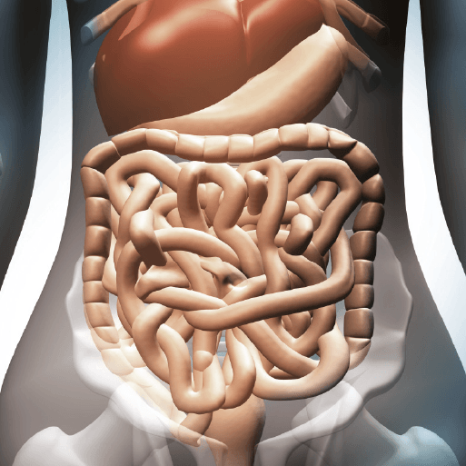

**Topic**

* In Science, our topic is all about the Human Digestive System, as well as the teeth of humans and other animals. Our topic this term is heavily focussed on Science, so we will be completing extra Science lessons compared to other terms.
* In DT, we will be looking at modelling the digestive system, creating our own one- this will include exploring how food travels through and out of the body…!
* For our RE lessons, we are going to continue learning about inspirational people, before moving on to look at religious festivals such as Diwali and Christmas.
* We will also be continuing with our weekly French, Computing, Music and PSHE lessons. In music we will be covering two shorter topics (The Pink Panther and Composing with Colour), in PSHE our new topic is cycle safety.

**PE**

* This term, PE will continue be on a **Friday afternoon**. Please ensure that children still come into school wearing their PE kit.

**Maths**

* Our first unit will be focused on area, looking at counting squares and comparing areas of different shapes.
* Then, we will be moving on to multiplication and division. The children will be learning the 3, 6 and 9 times table.
* Next, the children will be learning their 7, 11 and 12 times tables, as well as division facts.
* To conclude this unit, the children will be learning how to divide by 1 and 0, divide a number by 1 and itself and multiplying three numbers.
* Also, we will be continuing to practice our specific times tables for the weekly test.

**Literacy**

* This term, we are reading the novel Krindlekrax by Philip Ridley. We will be continuing to develop our skills in defining vocabulary, inference, making predictions, retrieval and summarising/sequencing events.
* In English, we will be focussing on three writing skills. They will begin by writing a persuasive letter to one of the characters from our core text. Then they will be writing a setting description about the location in our core text. Finishing off with a recount from the perspective of a character in the text.

Burps, Bottoms and Bile