Reception Newsletter- Summer 1

Welcome back! We hope you had a lovely Easter holiday and are looking forward to the summer term, we certainly are!
This half term, we have two mini projects – “Once upon a time” and then “Big Wide World.”
In Once upon a Time, we will be focusing on retelling classic stories using books, puppets and costumes. We will be creating our own storybooks and inventing plot twists for familiar stories.
In Big Wide World, we will be focussing on the continents of the world and different habitats and climates. We will be talking about journeys and travelling, and different countries and communities.
In maths over the half term we will be covering building numbers to 20 and counting patterns beyond 10, adding more and taking away. We will match, rotate and manipulate for spatial reasoning and learn about composing and decomposing shapes. We will be learning to double and halve quantities as well.
In phonics, the children have been assessed and will continue their phonics learning in small groups. Some children will have new teachers, this will be explained to you fully during parent’s consultations.
Please be mindful of the weather. Children should bring a hat to school in hot weather, as well as their water bottle. They should also have suncream applied before the start of the school day. We cannot reapply suncream in school hours.
Please also fill in the Easter Egg-cellence form as we like to display what you say about your children in our classroom.
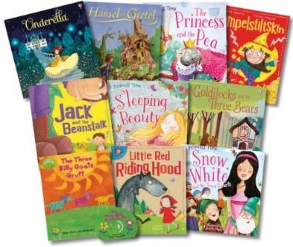
Kind Regards,
Mrs Divall, Miss Skelton and The Reception Team 🙂

