LONDON BOROUGH OF HAVERING

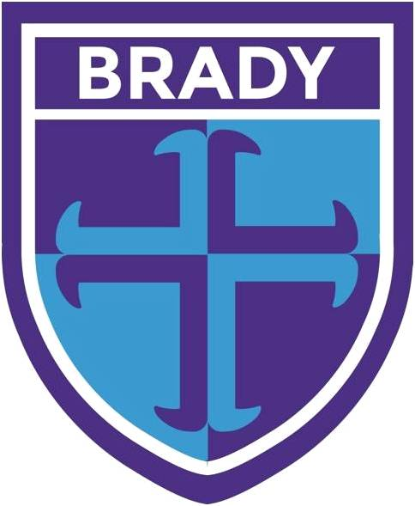

BRADY PRIMARY SCHOOL

UNIFORM POLICY

SUMMER 2021
BRADY PRIMARY SCHOOL

Mission Statement
“Inspiring teaching, for ambitious learners”

Purpose
The purpose of our uniform policy is that all parents are aware of the dress-code and expected presentation of children for Brady Primary School and that all children will wear our agreed uniform each day. This encourages a good standard of clean and tidy dress in school and is practical, maintainable and good value for money. Guidance on hair styles ensures we are health and safety compliant and that all children feel equal to each other. Please be aware that any child across the school not wearing the correct school uniform will be approached as to why and the parents will be asked to provide the correct uniform.

Aim
- To foster a feeling of belonging to our school community.
- To promote a feeling of pride in pupil’s own appearance and in their school.
- To ensure that children feel equal to each other, regardless of financial circumstances or other factors.
- To ensure that uniform and P.E kits satisfy the Health and Safety needs of the typical school day.

Jewellery
No jewellery is permitted in school, except for small stud earrings.

Jewellery is considered to be any form of adornment to the body, which is not clothing. This includes all kinds of earrings (other than studs) and bangles and is not permitted in school. Children will not wear any form of jewellery to school, in order to maintain their health and safety and equal appearance as part of the uniform policy.

Hairstyles
Long hair must be tied back and extreme hairstyles are not deemed suitable for school. Please note that this includes: shaved heads that expose skin or hair sculptures; such as lines, shapes, highlights, dyed or bleached, or coloured hair extensions that do not match the child’s natural hair colour. Beads in hair should not obscure a child’s normal vision and be kept to a minimum, in the school colours either black, navy blue or white. All hair must be kept to its natural colour.

How to purchase uniform
School uniform can be purchased from either Tesco (myclothing.com) or Premier School Wear (www.premierschoolwear.co.uk)

Please name all clothing items
Please ensure that all items of children’s clothing are clearly marked with their names, so that items found can easily be returned to their owners. Whilst every care is taken to ensure that children do not lose items of clothing, or other equipment, we cannot accept responsibility for any loss.

Winter and Summer Uniform
1st Autumn Half Term: Choice of Winter or Summer Uniform
2nd Autumn Half-Term: Winter Uniform
1st Spring Half Term: Winter Uniform
2nd Spring Half Term: Winter Uniform
1st Summer Half-Term: Summer Uniform
2nd Summer Half-Term: Summer Uniform

Outdoor Coats
The coat should be suitable for cold or wet weather; preferably with a hood. Ideally, coats should be dark in colour-navy blue or black.
Footwear
Black school shoes or ankle boots only- trainers are not allowed in school. Trainers are not allowed in most secondary schools and so this will help to ensure a smooth transition to a more formalised uniform at the end of your child’s primary career into secondary school. Please note that shoes that slip off easily are not suitable).

P.E Uniform Kits
Black/ dark blue jogging-bottoms.
Black/ dark blue shorts.
Black/ dark blue sweatshirt.
Blue P.E t-shirt with school logo.
Sports trainers and plimsolls.

Summer P.E Kit: Black/ dark blue shorts, blue P.E t-shirt with school logo, trainers and plimsolls.
Winter P.E Kit: Black/ dark blue jogging-bottoms, Black/ dark blue sweatshirt, blue P.E t-shirt with school logo, trainers and plimsolls.

Boys Uniform
Winter uniform
White shirt worn with School tie (ties can be purchased from the school office)
Logoed pullover, cardigans and jumpers available from our suppliers
Grey school trousers (not combat style)
Grey socks
Black school shoes (see footwear section)
Dark coloured school coat
Summer Uniform
White shirt worn with School tie (ties can be purchased from the school office)
School logoed polo shirt or plain white polo shirt
Logoed pullover, cardigans and jumpers available from our suppliers
Grey school shorts (optional and not combat style)
Grey school trousers
Grey socks
Black school shoes (see footwear section)
Girls Uniform
Winter uniform
White shirt worn with School tie (ties can be purchased from the school office).
Logoed pullover, cardigans and jumpers available from our suppliers
Grey skirt or pinafore
Grey school trousers (not combat style)
Dark blue/ grey tights or white socks.
Black school shoes (see footwear section)
Dark blue, white or black hair ribbons (no large bows or excessive hair decorations)
Beads should be kept to a minimum and in dark blue, white or black
Dark coloured school coat
Summer Uniform
White shirt worn with School tie (ties can be purchased from the school office)
School logoed polo shirt or plain white polo shirt
Grey skirt or pinafore
Grey school shorts (optional and not combat style)
Grey school trousers
Blue Gingham Dress
White socks.
Black school shoes (see footwear section)
School Book-Bag/ Rucksack
Children should all have a blue logoed school book-bag to keep reading books and homework safe, dry and undamaged (available from our suppliers). Children in Year 6 have the option to bring in their own rucksack.

Religious headwear
Headscarves/hijab:
These may be worn for religious reasons, but must be in designated school colours – either dark blue, white or black.

Lost items
Whilst every care is taken to ensure that children do not lose items of clothing, or other equipment, we cannot accept responsibility for any loss. Please ensure that all items of children’s clothing are clearly marked with their names so that items that are found can easily be returned to their owners.

