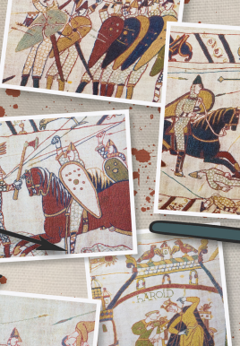
Key dates:
Friday 6th February 2026, Friends of Brady Pyjama Day

Topic
- In History, we will be going into depth about 1066.
- In Art, we are looking at animals where we will be sketching different animals and creating a clay sculpture of a Bankura horse.
- In Science, we will be learning about sound.
- We will also be continuing to study RE, Music, PSHE and French, as well as having time dedicated to handwriting and spelling.
PE
- This term, children have swimming on a Tuesday morning. Please ensure that they are wearing their swimming costumes under their P.E kits. Ensure they have a swimming cap, underwear and towel in their appropriate bag.
Can girls please make sure their hair is tied up.

Literacy
- This term, we are reading the book called ‘ the last bear’. We will be focussing on improving our skills in vocabulary, inference, predictions, retrieval and summarising.
- This term we will look at writing a non-chronological report on 1066 and a diary entry towards the end of the term.

Maths
Throughout this term, we will be:
- Revising multiplying and dividing
- Length and perimeter
- Fractions
- Continuing to practice times tables, including our weekly times table test.

1066

