In Nursery, our topics this half term are Celebrations and Exploring Autumn. Below are some examples of activities that we would like your child to take part in. Your child can complete as many of these activities as they wish to. We will display them in our classrooms. You can bring them in as soon as they have been completed. The final date for completion is 12th December 2025. ​
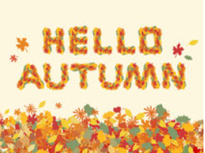
Go on an Autumn walk and crunch through leaves, catch falling leaves and collect acorns, conkers, blackberries and other autumn treasures. Bring these to school for us to explore!
Talk about events that you like to celebrate as a family. Look at photographs or video clips of you celebrating the different events. Draw a picture of your celebration.

People eat special food when they celebrate. What food is special to you? Can you try and make some of it with your grown up?

Make a collection of different Autumn treasures. Draw your Autumn collection or take a photograph of it.

Can you make some fingerprint lights and continue a repeating pattern? E.g. red, green, red, green, red, green
Visit the Library and have a look at some non-fiction books about Seasons. What did you find out?

Practice writing your numbers up to 10.
Draw an Autumn picture and a Winter picture. What is different about your pictures?
Collect 10 conkers or acorns. Count them carefully. Pick a number from 5–10 and find different ways of making the number with the conkers.
Choose your favourite leaves and use wax crayons to take leaf rubbings. You could also make a leaf print painting!
Can you recognise your name? Can you write some of the letters in your name?

Visit the CBeebies – Let’s celebrate website to find out more about
different celebrations that happen at this time of year. You could look up Diwali, Christmas and Hanukkah.
Shiny materials reflect light. When it is dark, take a torch and shine it on different objects around the house. Draw or make a list of the shiny and not shiny objects that you find.

