
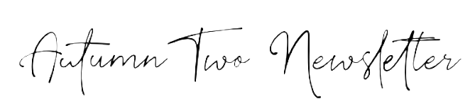

Dear Parents/ Carers,
We are so proud of how well the children have settled into Nursery. We hope you have had a lovely Half Term and are ready for a new one, packed with lots of learning and exciting things coming up.
At Brady, we follow topic themes each half term. This half term our topic is called “Celebrations (Sparkle & Shine)”. We will be learning about Diwali, Christmas, seasons, birthdays and other celebrations.
All children now have their very own reading record and they are given a different book to take home every week. Please remember to record your reads so that the children can work towards getting their reading rewards. If you have any questions about this, please ask one of the Nursery team.
PE sessions take place on Thursday afternoons. If your child attends Nursery on a Thursday afternoon, please send them to Nursery in their PE kits.
Nursery parental consultation days are on Wednesday 12th and Thursday 13th November. Please ensure you have booked a slot to discuss your child’s progress and time at Nursery so far. Details about the EYFS Nativity are coming soon! The last day of this term is Friday 19th December 2025.
As part of our topic, please send your child in with a photograph of them/ your family celebrating a special time. This could be a birthday, Christmas, Eid, Diwali, Hanukah, the birth of a sibling or anything that was a special time to them. Please be aware we would like to keep these photographs for a display (and return them before Christmas) so photocopies are fine! Please send these in ASAP and hand to an adult at the door.

Things to remember:
- Please ensure every single item of clothing is labelled
- Check the School Uniform policy carefully.
- Please bring a full change of clothes for us to keep at school in case of any accidents (this includes underwear and socks too, we would prefer this to be uniform but other clothes are also fine). Please ensure these are clearly labelled in a bag we can keep on your child’s peg.
Things to Bring to School Every Day
- A clearly labelled water bottle
- A Brady book bag/ rucksack
- A suitable coat and clearly labelled scarf/ hat and gloves (if needed)
- Your happy smiley selves!

Where can I keep up to date with things I need to know?
- Our school website is updated weekly with information and pictures of your children and their learning. www.bradyprimaryschool.co.uk You can log in and comment on any posts that we put up- it would be lovely to hear your feedback.
- We will send out texts/ emails when we need to update you with key dates and information, please make sure we have the correct details for you on role
- Keep a look out on the Nursery doors/ windows for posters with important information

I have attached a homework map. None of this is compulsory, but you could choose to do some or all these activities with your child at home and send in any work you do to display in class. Any support you give your children now will help them so much with their learning in school.

Important dates for your diaries:
- Wednesday 12th and Thursday 13th November – Parental Consultations
- Friday 14th November – Children in Need
- Wednesday 10th December – EYFS Nativity (AM)
- Thursday 11th December – EYFS Nativity (PM)
- Monday 15th December – Christmas Jumper Day and Christmas Dinner
- Friday 19th December 2025 – Last session of the term (no lunch or afternoon session) Nursery closes at 12pm

We are all looking forward to a fun-filled Half Term with lots of things to do and learn about. If you have any queries or any issues that may arise, please don’t hesitate to speak to us and we will always do our best to help you (the end of the session is best).

Kind regards,
Miss O’Sullivan, Mrs Hayes, Miss Raven, Miss Paige, Miss Michelle, Ms Spraggon and Miss Danielle 😊

