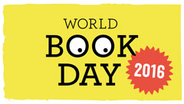

On Thursday 3rd March it is World Book Day. We would like the children to dress as a story character from these books.
Reception Charlie Cook’s favourite book.
Year 1 Snow White
Year 2 Peter Pan
Year 3 Harry Potter
Year 4 The Jungle Book
Year 5 Alice in Wonderland
Year 6 The Chronicles of Narnia
A donation of £1.00 for each child, will be sent to Book Aid international. Please send this to school with your child in the morning. Once all the money is collected, we can inform you of the amount raised.
I am sure the children will have a great day.

Yours sincerely

Mrs Askew Literacy lead

Jon Bishop
Headteacher

