Mathematics Policy

Brady Primary School

Reviewed October 2023
INTENT

Our vision for Mathematics at Brady Primary School

The language of mathematics is international. The basic skills of mathematics are vital for the life opportunities of our children. Our aim is for all children to think mathematically, enabling them to reason, solve problems and assess risk in a range of contexts.
At Brady Primary School our curated mastery approach has been developed to ensure every child can achieve excellence in mathematics. Children can experience a sense of pride and achievement as they solve a problem for the first time, discover different solutions and make links between different areas of mathematics. It provides pupils with a deep understanding of the subject through a concrete, pictorial and abstract approach. This ensures pupils fully understand what they are learning.

Key features of our Maths Mastery curriculum:
- High expectations for every child.
- Progressive topics facilitating Greater Depth (GDS).
- Number sense and place value come first.
- A focus on mathematical thinking, reasoning and language.
- Resources to support all learners.
- Problem solving is central.
- Children calculate with confidence – they understand why it works.

Mathematics mastery places emphasis on the cumulative mastery of essential knowledge and skills in mathematics. It embeds a deeper understanding of maths by utilising a concrete, pictorial, abstract approach so that pupils understand what they are doing rather than just learning to repeat routines without understanding what is happening.

IMPLEMENTATION
The teaching of Mathematics at Brady Primary School

EYFS (Early Years Foundation Stage)

Teachers will use the phases outlined in the White Rose Maths Scheme of Learning for EYFS and are free to supplement their teaching with other resources, including ‘Master the Curriculum’ that match the intended learning goals. The phases of the Scheme of Learning are a guide for teachers to ensure coverage of the EYFS maths curriculum. Teachers are free to make adaptations to the progression or order of the phases to meet the needs of the learners in their class.

Years 1-6
These Year Groups will be fulfilling the criteria of the National Curriculum for Mathematics (2014) with a focus on developing ‘Mastery’ of that Year Group’s content using the long term, medium term and short-term planning of the White Rose Maths Scheme of Learning (SoL). By following the small steps of this scheme, teachers will be developing the children’s skills in a progressive, logical way and will be able to address misconceptions in prior learning. Coverage will be progressive, logical and allows time for the teachers to extend or truncate learning to meet the needs of their class.

With this in mind, these cohorts will build their skills using Concrete, Pictorial and Abstract representations of Mathematics, in line with a ‘Mastery’ approach to learning.

Class teachers are free to supplement White Rose Maths small steps progression using resources from Classroom Secrets, NCETM, Nrich, Twinkl and Target Your Maths to build engaging and challenging lessons for their pupils and to meet their individual needs.

Brady Primary School uses two main methods for children to record their learning:

White Rose Maths worksheets.

These worksheets are tailor made for the progression found in the Scheme of Learning. Each worksheet becomes increasingly more challenging and provides opportunities for varied fluency, reasoning and problem-solving. These are mainly used in Key Stage 1, but Key Stage 2 teachers have the option of using them for specific lessons, topics or blocks if they are more suitable for their needs.

The challenge system (Curated mastery)

Brady Primary teachers can use a challenge system for Learning Objectives and challenges within our maths lessons to aid children in understanding and reflecting upon their daily learning. Children will self-assess against their learning to show their own understanding of their progress. Every child will have the opportunity to experience varied fluency, problem-solving and reasoning challenges in every lesson.

Within the challenge system each child will have the opportunity to experience varied fluency, reasoning and problem-solving skills. Using a simple colour progression of: blueblackgreen (ARE)purple (GDS), children will experience a range of problems that will both challenge them and show progression, while also allowing the children and teachers to make accurate assessments about progress and attainment. Children who demonstrate an understanding at the Greater Depth standard will be extended to leverage their deeper understanding and reasoning skills.

A more detailed breakdown of how calculations are taught, embedded and further developed can be seen in our separate Mathematics Calculation Policy.

The progression of skills for the four operations across Brady Primary School, including the Concrete, Pictorial, Abstract approach:

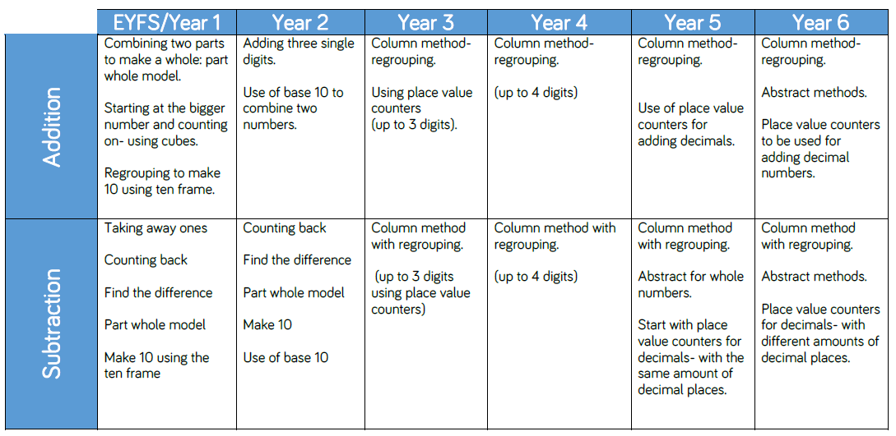

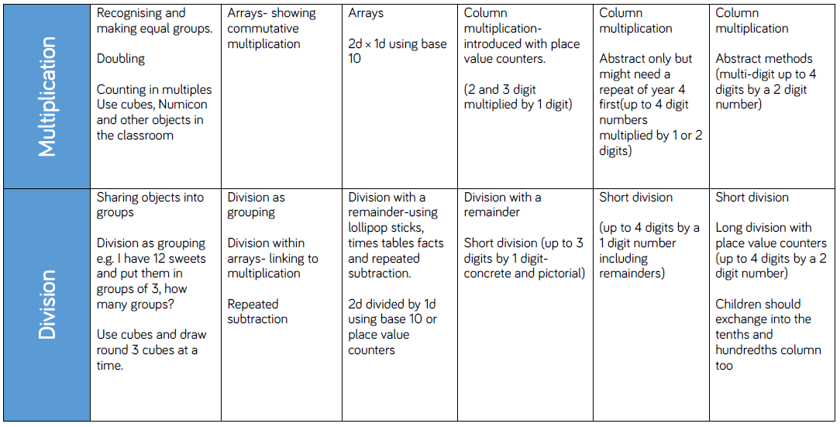

IMPACT
The assessment of Mathematics at Brady Primary School

EYFS

Formative Assessment:
Teachers will assess each child against the Early Learning Goals (ELGs) in the specific areas of Number and Numerical Patterns. The White Rose Scheme of Learning is used for the spine of the teaching and assessment.

Summative Assessment:
At the end of the EYFS, teachers will use teacher assessment and professional judgement to determine children’s progress against the ELGs. This information will be shared with all stakeholders, and then the Year One teachers to plan their teaching sequences for the next academic year.

Years 1 & 2

Formative Assessment:
Teachers will assess each child using the White Rose Maths activity worksheets that are directly linked to each small step’s Learning Objective as well as the White Rose Maths end of unit assessments to make teacher assessment judgements about the attainment of each child. These formative assessments are ongoing, but are recorded each term. These teacher assessments form part of the discussion teachers have with parents at parent meetings and with the leadership team at Pupil Progress Meetings.

Summative Assessment:
Towards the end of the KS1, while in Year 2, children will sit a formal set of assessments (KS1 SATs) under test conditions. Using government-produced thresholds, teachers will report whether children are working at the Expected Standard (EXS) for Year 2. Judgements for Mathematics will either be internally moderated, or externally moderated via official visits from the Local Authority Moderation team.

Years 3, 4 & 5

Formative Assessment:

Teachers will assess each child using a combination of the challenge system, where green relates to ‘Age-Related Expectation’ and purple relates to ‘Greater Depth’, as well as the White Rose Maths end of unit assessments to make teacher assessment judgements about the attainment of each child. These formative assessments are ongoing, but are recorded in Autumn 1, Spring 1 and Summer 1 terms. These teacher assessments form part of the discussion teachers have with parents at termly parent meetings.

Summative Assessment:

At the end of each term, children will sit formal assessments under test conditions. Using approximate thresholds based on end of KS2 assessments, teachers will record whether children are children are Working Towards (WT) the expectations for their year group, meeting age-related expectations (EXS) or working at a standard showing a deeper Greater Depth (GDS) understanding of the year group’s Maths objectives.

Year 6

Formative Assessment:

Teachers will assess each child using a combination of the challenge system, where green relates to ‘Age-Related Expectation’ and purple relates to ‘Greater Depth’, as well as the White Rose Maths end of unit assessments to make teacher assessment judgements about the attainment of each child. These formative assessments are ongoing, but are recorded in Autumn 1, Spring 1 and Summer 1 terms. Additionally, teachers may use past paper examinations to identify specific gaps in each child’s knowledge as part of a routine assessment for learning (AFL) cycle. These teacher assessments form part of the discussion teachers have with parents at termly parent meetings.

Summative Assessment:
In May of KS2 children will sit a formal set of externally marked assessments (KS2 SATs) under test conditions. Using government-produced thresholds, children will be judged as having not met (HNM) the standard of the KS2 assessments or having met the standard (EXS). These assessments are reported to parents in each child’s school report.

