March 2022

Dear Parents/Carers,

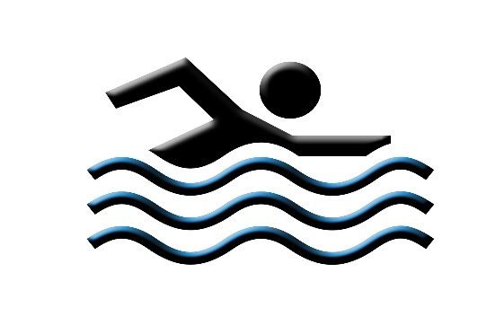

SWIMMING – Year 4, April 2022

Please be advised that Year 4 children will be going swimming next term. The actual dates are:

Thursday 28th April
Thursday 12th May
Thursday 19th May
Thursday 9th June

Children will travel by coach to Central Park Leisure Centre in Harold Hill. They will leave Brady between 10.00-10.15 am and leave the leisure centre at 11.40am. Arrangements will be in place to ensure children have plenty of time to eat their dinner on their return.

Children must come to school in their PE kit and bring a one-piece swimming costume/trunks and towel, in a waterproof bag. Swimming hats must also be worn.

To avoid clothing getting lost/mixed up, please ensure your child’s PE kit is labelled.

Thank you.

