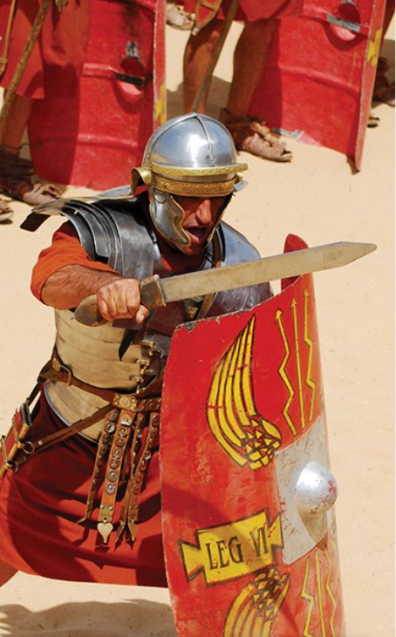

**Literacy**

* Imagine you are a Roman soldier who has come to England, writing a letter home to your family who still live in Rome. They can find out from the letter about where the soldier is living, their work and everyday life.
* Create freeze frames around your home/outside describing Boudicca’s life and her journey to becoming the leader of The Iceni Tribe. Take photos of the freeze frames and then print/send them to Miss Smith.
* Imagine that you are either a Celtic or Roman warrior. Draft a short soliloquy entitled ‘I am Warrior’, presenting your thoughts as they prepare for battle. Imagine what you would feel, think and fear.
* **Read at least five times a week at home.**

**Geography**

* Find out about similarities and differences between Italy and Britain, including climate, landscape, size and weather. Use maps, globes and geographical information books to research their information and record their findings using appropriate software to create a table to illustrate the differences that they discover.
* How many Roman towns can you find in the UK? Record your findings in a simple table or spreadsheet.

**Maths**

* Practice reciting and writing out Roman Numerals up to 100
* Keep practicing times tables every day
* Continue to practice using a variety of written methods for addition and subtraction

**Art and Design**

* Follow a recipe for the staple food of a struggling Roman family. Make simple porridge or bread, following original recipes. Compare this meal with the foods of the rich. Who would you rather be?

**History**

* Construct a profile of a significant leader that we have learnt about, using a range of different sources
* Find out about the everyday life of a Roman child, using a selection of historical source materials. Work in research teams to find out about homes, clothes, schools, entertainment, religion and meal times. Present a thoughtful selection of relevant information in any form you choose.

I am Warrior!