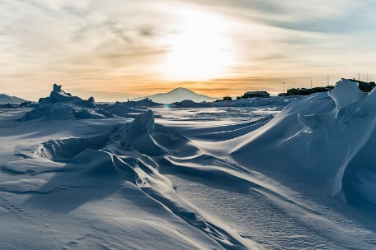

**Geography**

* Find out what natural resources and raw materials are reaped from the Arctic. What impact does this have on the environment?

**Frozen Kingdom**

**Science**

* Imagine a common domestic animal became an inhabitant of the Arctic or Antarctic. How would it have to adapt to survive there? Longer, thicker hair? What else? Rename your common animal with a more exciting ‘polar’ name!

**Maths**

* Practise using fractions will all 4 operations.
* Revise ordering and comparing fractions with different denominators.
* Find fractions of different amounts.

**Art and Design**

* Use a range of snowy images to create a polar collage. Remember to use lots of interesting textures, shapes, colours and patterns.
* Make ‘iced jewels’. Mix powder paints and dyes into water, in an array of colours. Pour into an ice cube tray before freezing overnight. Pop the cubes out and explore your iced jewels. What happens if you sprinkle salt on the cubes?
* Make a model of your favourite Arctic animal using clay, dough or recycled materials. Take it into school and explain how you made it.
* Design a pair of snow boots for an Arctic explorer. What materials would you use? What features could they have? Let your imagination run wild!

**Computing**

* Research the Titanic – create a PowerPoint with information about the ‘unsinkable’ ship.
* Find out about other people who have explored the Antarctic using the internet or by visiting the library – create a fact file about these explorers.

**Literacy**

* Imagine that Earth has entered another Ice Age. Write a diary-style piece describing the changes and how the human race has adapted to cope.
* Create your own Arctic and Antarctic word search puzzles using all the new words you have learned during the project. Challenge an adult to solve it!
* Create a poster or brochure for a new travel company which arranges visits to the Arctic or Antarctic. Use powerful images and text to tempt customers who want an extra-special trip!
* *Continue to practise spellings and read daily.*