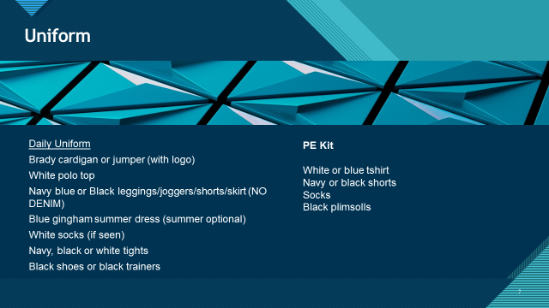

NURSERY UNIFORM FOR BRADY PRIMARY

Available from [www.premierschoolwear.co.uk](http://www.premierschoolwear.co.uk) or www.myclothing.com