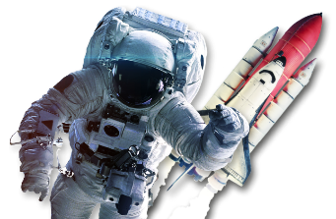

**English**

The company SpaceX are developing a new spacecraft to carry people to Mars. Imagine that you have been asked to provide travel guidance to interplanetary travellers. Create a leaflet about Mars to convince people to visit. Find out key facts and suggest the best places to visit and what to pack. Use persuasive language to appeal to your audience of potential visitors.

**History**

Find out about a significant space scientist and write a biography or fact file about their life and work. Examples include Claudius Ptolemy, Ibn Al-Haytham, Edwin Hubble, Stephen Hawking or Mae Carol Jemison.

**Science**

Use a range of sources to find out about the planets in our Solar System, such as their diameter, position from the Sun, number of moons, day length, year length and type, for example gaseous or terrestrial. Record your results in a table.

Use books or the internet to find out how the Earth’s rotation causes day and night and discuss this with an adult. Model the action of the Sun and Earth and how they create day and night using a ball (to represent Earth) and a torch (to

represent the Sun). Write a short paragraph to explain day and night.

Use an app to help you to locate features in the night sky. Examples include natural objects, such as the Moon, planets, constellations and nebula, or man-made objects, such as the International Space Station or Starlink satellites. Choose how to record your observations.

Before clocks and watches were invented, people used sundials to measure the passage of time. Make a shadow clock or sundial, using instructions found online. Use your creation to tell the time and consider how accurate it is compared to modern clocks. Explain to an adult how your shadow clock or sundial works, describing the movement of the Earth relative to the Sun in your explanation.

Keep a Moon diary over the course of a lunar month. Draw the shape of the Moon each night, finding out and recording the correct term for each lunar phase.

Find out about the following types of moon: blood moon; supermoon; blue moon

and harvest moon. Why have they been called this? When do they happen? How

often can you see a moon like that?

Year 5 - Stargazers