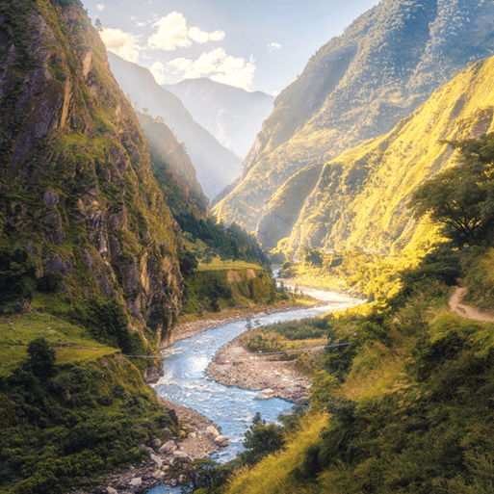

**PE**

* This term, PE/swimming will continue be on a Tuesday morning. Please ensure that children still come into school wearing their PE kit with all of their swimming kit: swimming hat, costume/trunks and a towel.

**Maths**

Throughout this term, we will be:

* Continuing with our topic on Fractions, looking at improper fractions and converting between mixed and improper.
* Our next topic will be Decimals. This topic follows on from fractions, looking at how we convert tenths and hundredths into decimals.
* At the end of the term, we will be consolidating what we have learnt so far.
* Every week we will be completing our times table tests, with the children aiming to pass at least one level every half-term.

Misty Mountain, Winding River

**Literacy**

* This term, we are continuing reading the novel The Lion, the Witch and the Wardrobe by C.S. Lewis. During our reading lessons, we will be persevering with developing our skills in defining vocabulary, inference, making predictions, retrieval and summarising/sequencing events.
* In English, in our first unit the children will be practicing their letter writing skills, by writing a letter home to their families from their (fictional!) holiday. We will then be working on writing narratives based on the Lion, the Witch and the Wardrobe.

**Topic**

* In Geography, we will continue looking at rivers and mountains, focussing especially on mountains this half-term. This will include how they are formed, and famous mountains in the world and in the UK.
* In DT, the children will using their sewing skills as we explore different types of fabric.
* In Science, our topic is Electricity. The children will be exploring how to work with electricity safely, as well as making their own circuits.
* For our RE lessons, we are exploring how different religions view the creation of the world, and then comparing the creation stories of different religions such as Judaism and Christianity.
* The children will continue to learn French weekly, with our topic this term being ‘Animals’, as well as weekly Computing, Music and PSHE lessons.