In Reception this Half Term we have two projects. Here are some examples of activities that we would like your child to take part in for each project. You should aim to complete and send in evidence of at least three of these activities – you can also send this in via the school website. You can send them in as soon as they have been completed. The final date for completion is the 20th May 2022.
Big Wide World
Once Upon a Time
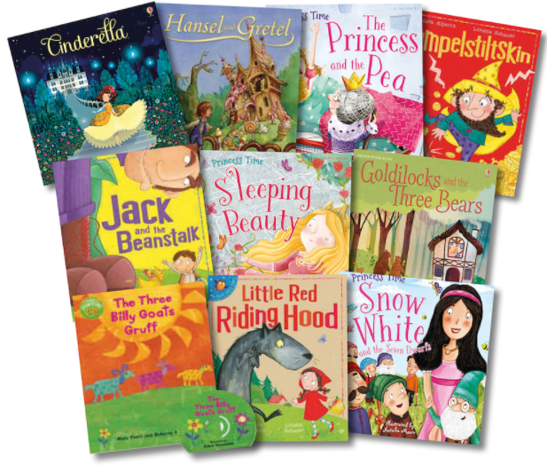

Watch a pantomime together or read a favourite story. Discuss the storyline and different characters. (Recorded pantomimes can be found online).
Read the story of Goldilocks and the Three Bears. Afterwards, make some porridge using oats and milk/water. Try some different toppings
Ask people in your family/ your friends where they would like to visit in the world. Record this as a tally chart or bar chart.
Look at photos of holidays/trips you have taken. How did you travel there and what did you do? Send us some pictures and write some sentences.

Read Little Red Riding Hood. Make a wanted poster for the wolf with a picture and some words/ captions to describe him.
Practice your addition and subtraction. Can you add some more and find less than a given number?
Find a world map and circle the United Kingdom. Then, go on Google maps and use the search bar to find some different places. Colour these in and label them.

Read Three Billy Goats Gruff. Draw a map to show where the characters live. Retell the story using the map.
Practice your handwriting. You should know how to write the alphabet in lower-case and capital letters. Focus on letter formations too.

Go to the Library and find a book about the United Kingdom. Create a poster with some interesting facts.
Visit Google Earth and research a famous structure. Choose your favourite and draw and label it. Some examples include Taj Mahal, Colosseum and Burj Khalifa.

Make some puppets of your favourite fairy tale characters. Use them to act out and re-tell the stories.
Read The Three Little Pigs. Design a new house for the pigs. You could use blocks, sticks or straw. Which one was the strongest?
Can you find out where the following animals live around the world?
- Panda
- Lion
- Penguin
- Koala
Practice writing your numbers to 20 and ordering numbers to 20.

Make some yummy Gingerbread men
Listen to some music inspired by fairy tales/ traditional tales. See if you can move in relation to the music.
Design a flag. Label the shapes and colours you have used.

Choose your favourite animal from anywhere in the world. Draw a picture of it and write three interesting facts.

