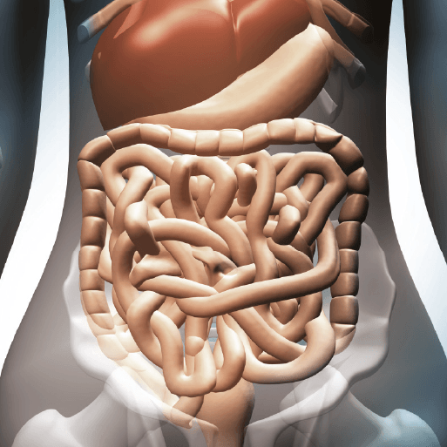

**PE**

* This term, PE is now going to be on a **Thursday morning**. Please ensure that children still come into school wearing their full PE kit.

**Maths**

Throughout this term, we will be:

* Continuing with our topic on Decimals, including comparing, ordering and rounding decimals.
* Our next topic will be Money. As well as recapping concepts such as adding and subtracting money, we will be learning how to order and estimate amounts of money.
* For our final topic in Summer 1, the children will be learning all about Time. Please practice reading the time on analogue clocks at home.
* Every week we will be completing our times table tests, in preparation for the multiplication check in Summer 2.

**Literacy**

* This term, we are beginning to read the novel Alice in Wonderland by Lewis Carroll. During our reading lessons, we will be continuing to develop our skills in defining vocabulary, inference, making predictions, retrieval and summarising/sequencing events.
* In English, our first writing unit will be a non-chronological report. The children will be writing a report on teeth, including different types and their functions. The second piece of writing the children will be completing is a balanced argument, where they will be putting forward valid and concise arguments.

Burps, Bottoms and Bile

**Topic**

* In Science, our topic is all about the Human Digestive System, as well as the teeth of humans and other animals. Our topic this term is heavily focussed on Science, so we will be completing extra Science lessons compared to other terms.
* For our RE lessons, the children will be learning about how believers from different religions show their commitment through the journey of life.
* The children will continue to learn French weekly. This term they will be learning vocabulary used to describe food and items used in restaurants/the kitchen.
* In DT, we will be looking at modelling the digestive system, creating our own one- this will include exploring how food travels through and out of the body…!