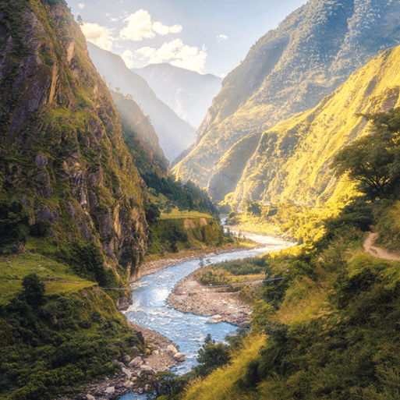

**Various**

* Create a collage-style version of an image similar to the one on this page, including a river and a mountain. You can use tissue paper, pens/pencils, oil and any other materials you find. Be as creative as possible!
* Find 10 worldwide mountains, including mountains in the United Kingdom. Mark and label the mountains on a world map and include a key.
* Enjoy a riverside or hilltop walk with your family. Before your outing, explore the area using an Ordnance Survey map to examine the contour lines, grid references and other features. When you arrive home, write a diary entry about the day. Include the date, events in chronological order, facts and your thoughts and feelings.
* Use an atlas, map or online tool, such as Google Earth, to find a range of rivers worldwide, including rivers in the United Kingdom. Trace each river’s journey by locating the source and following the river’s course to its mouth.

**Maths**

* Keep practicing your times tables at home at least once a week. This includes going onto Times Table Rockstars at least once a week too.
* Ask your family to challenge you and convert fractions into decimals- what is 1/10 as a decimal?
* Convert improper fractions into mixed numbers and vice versa- what is 9/4 as a mixed number?

**Literacy**

* You must continue to read at least 5 times a week at home. This can be any days that suit your timetable at home, but an adult must sign the child’s reading record after they have heard them read.
* Create a fact file on a mountain of your choice; this could be one in the UK or anywhere in the world. Think about what important information you would include in it: height, what country it is in, how many people have climbed it…
* Write a persuasive argument convincing someone that your favourite mountain in the world is the best mountain compared to other mountains. Why is it better? Is it taller? Is it the most dangerous to climb?

Misty Mountain, Winding River