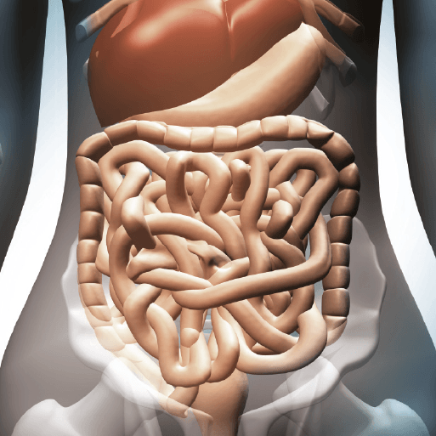

**PE**

* This term, PE will continue be on a **Tuesday morning**. Please ensure that children still come into school wearing their PE kit.

**Maths**

* Our first unit will be focused on area, looking at counting squares and comparing areas of different shapes.
* Then, we will be moving on to multiplication and division. The children will be learning the 3, 6 and 9 times table.
* Next, the children will be learning their 7, 11 and 12 times tables, as well as division facts.
* To conclude this unit, the children will be learning how to divide by 1 and 0, divide a number by 1 and itself and multiplying three numbers.
* Also, we will be continuing to practice our specific times tables for the weekly test (still on Tuesday mornings).

**Literacy**

* This term, we are reading the novel Rumblestar by Abi Elphinstone. We will be continuing to develop our skills in defining vocabulary, inference, making predictions, retrieval and summarising/sequencing events.
* In English, we will be focussing on two writing skills. They will begin by writing their very own Playscript. This will be based on an Anglo-Saxon play, and the children will write the next scene of the play. Then, the children will be writing a non-chronological report based on teeth.

Burps, Bottoms and Bile

**Topic**

* In Science, our topic is all about the Human Digestive System, as well as the teeth of humans and other animals. Our topic this term is heavily focussed on Science, so we will be completing extra Science lessons compared to other terms.
* In DT, we will be looking at modelling the digestive system, creating our own one- this will include exploring how food travels through and out of the body…!
* For our RE lessons, we are going to continue learning about Judaism, before moving on to look at religious festivals such as Diwali and Christmas.
* We will also be continuing with our weekly French, Computing, Music and PSHE lessons. In French, we will be looking at colours and numbers up to 20. In Computing, the children will be adding to their research and coding skills.