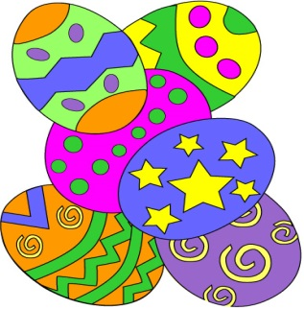

Dear Parents and Carers,
On Wednesday 23rd March we would like to invite you to see the Infant Easter hat parade. It will start at 2.00. The FOB will be serving tea and coffee after until 3.10.
We would like your child to make an Easter bonnet/hat for the parade. You can use any materials but make sure that they can wear it for the parade! These will be judged and there will be 2 winners in each class.
Hats must be brought to school on the morning of the 23rd March with names clearly marked. The children will be parading to the Juniors earlier in the day.
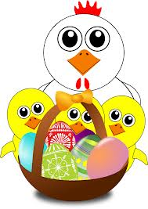
We hope to see you on the 23rd March.
Thank you
Mrs Askew

