World Book Day competition.
Design a bookmark for celebrating World Book day. All entries to Mrs Askew by Tuesday 28th February. Winners announced on Thursday 2nd March.

Name Class
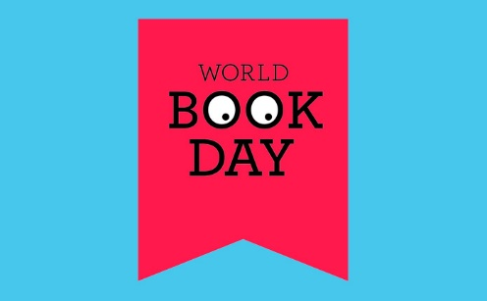
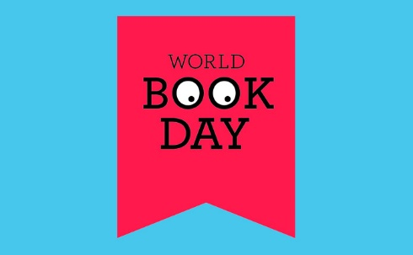

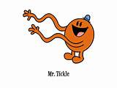
World Book Day competition
We all know the Mr Men characters but can you invent a new one?
Draw a picture and write about this character. Remember it has to be a new one!
All entries to Mrs Askew by Tuesday 28th February. Winners announced on Thursday 2nd March.
Name Class

…………………………………………………………………………………………………………………………..
…………………………………………………………………………………………………………………………
…………………………………………………………………………………………………………………………
…………………………………………………………………………………………………………………………
……………………………………………………………………………………………………………………………
………………………………………………………………………………………………………………............

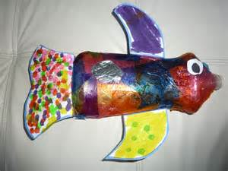

World Book day Competition
Make a story character from a plastic bottle. Use different materials. Entries can be put in the hall with a clear label of who the character is and who made it! Winners announced on Thursday 2nd March.

My character is…………………………………………………………………………

Made by ……………………………………………………………………………………

Class ………………………………..

