In Nursery, our topic this half term is, ‘Once Upon a Time’. This means that much of our work will be centred around traditional tales. Here are some examples of activities that we would like your child to take part in. You should aim to complete and send in evidence of at least three of these activities. We will display them in our classrooms. You can bring them in as soon as they have been completed. The final date for completion is 15th October 2021. ​
Think about your favourite story and try to retell this to your Mummy/ Daddy as a bedtime story.
Visit the library and select a range of Traditional Tales to read and share.

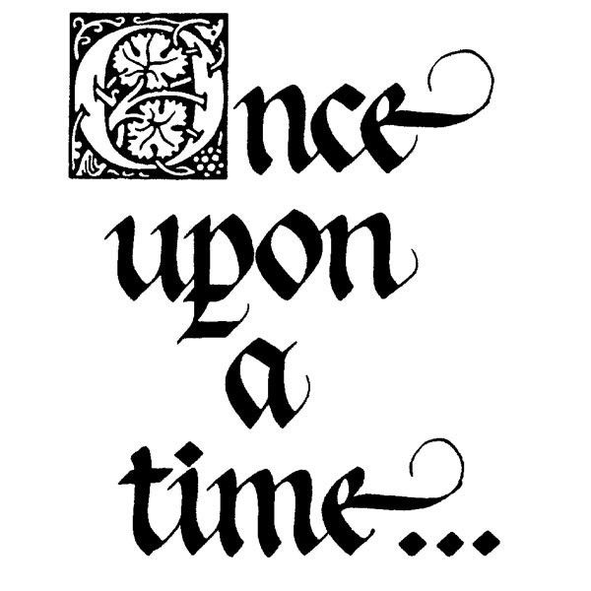
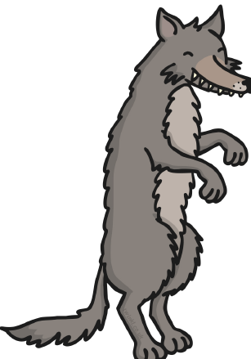
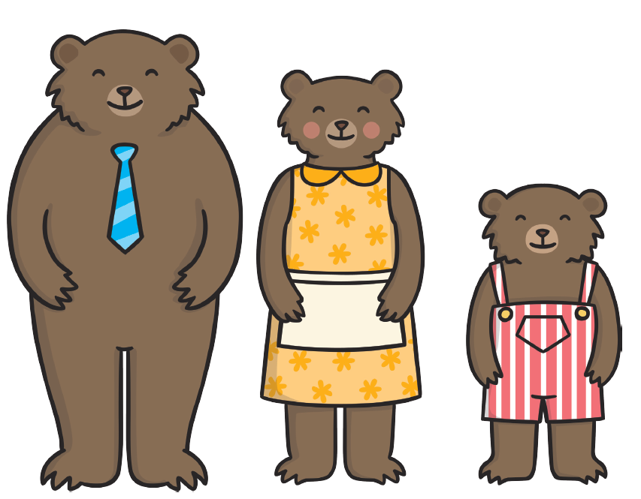
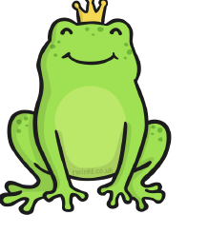
Count out ‘magic beans/ coins’ focus on counting accurately when the beans/ coins are in a straight line.
Make puppets from a Traditional Tale and hold a puppet show.
Measure different plants in the Garden to find out which is the tallest/ shortest ‘beanstalk’.
Prepare a picnic basket that Red Riding Hood could have taken to Granny’s house.

Make a 3D model of a scene from a Traditional Tale that you know well. You could use a shoebox, junk box modelling, create a 3D poster…
Act out your favourite traditional tale and take photos of your performance.

