Brady Primary School

Internet, E-Safety & Social Media Policy
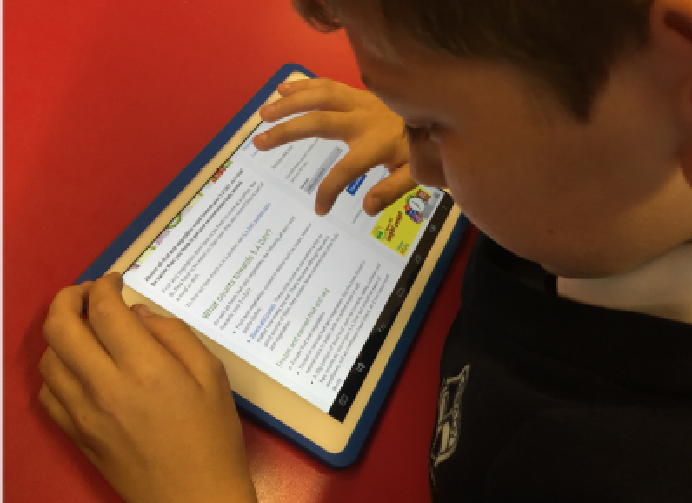

Aims of Brady Primary School

“All children can learn considerably more”

At Brady Primary School we aim to provide a safe, caring and stimulating environment, which offers opportunities:-

- For everyone within the school to reach their full potential and develop self-worth, self-confidence, the ability to take responsibility for their own individual actions, and resilience.

- For everyone within the school to have a sense of wonder, an enthusiasm for learning and help children to develop as independent thinkers and learners with enquiring minds.

- To encourage and develop a respect and understanding for others.

- To develop all partnerships, small and large, from the individual parent to the wider community and beyond to support children’s learning.

- To give children access to a broad and balanced creative curriculum to attain the highest possible standards in relation to prior attainment through assessment, teaching and learning.

Equal opportunities and Inclusion

At Brady Primary school we believe that every child is entitled to equal access to the curriculum, regardless of race, gender, class or disability.

We are committed to promoting learning and teaching environments, for all that embed the values of inclusive educational practices.

Through a child centred approach, we aim to ensure that education is accessible and relevant to all our learners, to respect each other and to celebrate diversity and difference.

INTRODUCTION:
As in any other area of life, children and young people are vulnerable and may expose themselves to danger- knowingly or unknowingly- when using the Internet and other digital technologies. Examples of e-Safety issues include:
- Exposure to inappropriate material
- Cyberbullying via websites and mobile phones
- Uploading personal information about themselves
- Threat of danger from making contact with a criminal minority via chat rooms and social networking sites
- Advocating extreme and dangerous behaviour such as self-harm or violent extremism.

Why is Internet use important?

Internet use is part of the national curriculum and a necessary tool for learning. The internet is a part of everyday life for education, business and social interaction. The school has a duty to provide students with quality internet access as part of their learning experience. Pupils use the internet widely outside of school and need to learn how to evaluate information and to take care of their own safety and security. The purpose of internet use in school is to raise educational standards, to promote pupil achievement, to support the professional work of staff and to enhance the school’s management functions. Internet access is an entitlement for students who show a responsible and mature approach to it’s use.

How can Internet use enhance learning?

The school’s internet access will be designed expressly for pupil use and will include filtering appropriate to the age of the pupils.
Pupils will be taught what internet use is acceptable and what is not and given clear objectives for internet use.
Internet access will be planned to enrich and extend learning activities.
Access levels will be reviewed to reflect the curriculum requirements and age of pupils.
Staff should guide pupils in online activities that will support the learning outcomes planned for the pupils’ age and maturity.
Pupils will be educated in the effective use of the internet in research, including the skills of knowledge location, retrieval and evaluation.
Pupils will be taught to acknowledge the source of information used and to respect copyright when using internet material in their own work.

How will Pupils learn how to evaluate Internet content?

If staff or pupils discover unsuitable sites, the URL (address) and content must be reported to the Local Authority helpdesk via the online safety coordinator or network manager.
The school should ensure that the use of internet derived materials by staff and pupils complies with copyright law.
Pupils should be taught to be critically aware of the materials they read and be shown how to accept and validate information before accepting its accuracy.
Pupils will be taught to acknowledge the source of information and to respect copyright when using internet material in their own work.

Information System Security

The security of the school information systems and users will be reviewed regularly.
The School uses robust security provision and a managed educational network service through LGFL.
Portable media may not be used without specific permission followed by a virus check.
Unapproved software will not be allowed in pupils’ work areas or attached to email.
Files held on the school’s network will be regularly checked.
The ICT Subject Leader/ Network Manager will review system capacity regularly.

Email Use in School

Pupils may only use approved email accounts on the school system.
Pupils must immediately tell a teacher if they receive an offensive email.
Pupils must not reveal personal details of themselves or others in email communication, or arrange to meet anyone without specific permission from an adult.
Whole class or group email addresses will be used for communication outside of the school.
Email sent to external organisations should be written carefully and authorised before sending in the same way as a letter written on school headed paper.
The forwarding of chain messages is not permitted.
Staff should only use school email accounts to communicate with pupils as approved by the Senior Leadership Team, following Local Authority guidance.

Published Content and The School Website

The contact details shown on the school’s website are that of the school.
This will also include the school’s email address and telephone number.
Staff or pupils personal information will not be published.
The Headteacher will take overall editorial responsibility and ensure the content is accurate and appropriate.
The website will comply with the school’s guidelines for publications including respect for intellectual property rights and copyright.

Publishing Pupil’s Images and Work

The school will use images of children on the school website only under the direction of the headteacher.
Photographs published on the website do not have full names of pupils attached.
Parents must inform the school office if they do not want images of their child to be electronically published.

Photographs/Video taken by Parents/Carers for Personal Use

In the event of parents/carers wanting to take photographs of children e.g. at school performances or on school trips, they are reminded that these are for their own private retention and not for publication in any manner including social networking sites such as Facebook.

Social Networking-Pupils

Social networking sites include, but are not exclusively, Facebook, Twitter, Instagram, Snapchat, Email, Blogs, LinkedIn, YouTube, Myspace and Bebo.
Within school the access to social media and social networking sites will be controlled.
Pupils will be advised never to give out personal details of any kind which may identify them and/or their location.
If personal publishing is to be used with pupils then it must use age appropriate sites suitable for educational purposes.
Personal information must not be published and the site should be moderated by school staff.
Pupils are advised not to publish specific and detailed private thoughts especially those that may be considered threatening, hurtful or defamatory.

Social Networking-Staff and Parents/Carers

Staff are expected to conduct themselves in any social media forum as they would in school.
Staff are also reminded to adhere to the guidelines regarding photographs of children for their own private retention.
It is inappropriate for staff to “friend” any child of primary school age.
Staff and parents/carers are reminded that social media sites should not be used as a forum for public debate, complaint or grievance regarding school issues and they should refer to the appropriate complaints or grievance policy.
References should not be made to any staff member, pupil, parent unless prior permission has been obtained and agreed with the HeadTeacher

Cyber bullying

Cyber bullying is bullying through the use of communication technology like mobile phone text messages, emails or websites. This can take many forms for example:
- Sending threatening or abusive text messages/picture messages or emails, personally or anonymously
- Making insulting comments about someone on a website or social networking site e.g. Facebook.
- Making or sharing derogatory or embarrassing videos of someone via mobile phone/tablet or email.
Brady Primary School will not tolerate any form of cyber bullying (whether inside or outside of school) to another pupil or member of staff and may take further action against any individual concerned.

Filtering

The school will work with LGFL to ensure that systems to protect pupils and staff are continually reviewed and improved.
If staff or pupils discover unsuitable sites, the URL must be reported to the online safety coordinator.
The schools broadband access will include filtering appropriate to the age and maturity of pupils.
Senior staff will ensure that regular checks are made to ensure that the filtering methods selected are appropriate, effective and reasonable.
Any material that the school believes is illegal must be reported to appropriate agencies such as IWF or CEOP.
The schools access strategy will be designed to suit the age and curriculum requirements of the pupils.

Managing Emerging Technologies

Emerging technologies will be examined for educational benefit and a risk assessment will be carried out before use in school is allowed.
Mobile phones will not be used during lessons or formal school time.
The sending of abusive or inappropriate texts, picture or video messages is forbidden.

Protecting Personal Data

Personal data will be recorded, processed, transferred and made available according to the Data Protection Act 2003.

Assessing Risks

The school will take all reasonable precautions to prevent access to inappropriate material. However, due to the international scale and linked internet content it is not possible to guarantee that unsuitable material will never appear on a school computer.
Neither the school nor the local authority can accept liability for the material accessed, and consequences of internet access.
The school will audit ICT use to establish if the online safety policy is adequate and that the implementation of the online safety policy is appropriate.

Handling Online Safety Complaints

Complaints of internet misuse will be dealt with by a senior member of staff.
Any complaint about staff misuse must be referred to the headteacher.
Complaints of a child protection nature must be dealt with in accordance with child protection and safeguarding procedures.
Pupils and parents will be informed of the complaints procedure.

Review
This policy will be reviewed annually by the Headteacher. Any alterations that come from this review will be discussed with the Headteacher and ratified by the teaching staff and appropriate governing body sub-committee.

Chair of Governors …………………………………………………………… Date ……………………………..

Headteacher ………………………………………………………………………. Date ……………………………..

