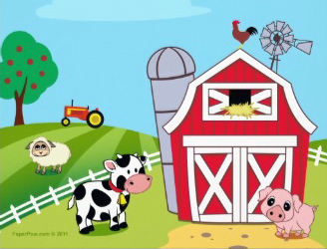

You may be aware that Tesco are involved in a nationwide initiative called Farm to Fork. They are allowing children the opportunity to visit stores and get closer to the food they eat.
I have arranged visits for the Infants to visit the local Tesco store in Rainham.
Year 2 will visit on Tuesday 20th January at 9.45
Year 1 on Wednesday 21st January at 9.45
Reception on Tuesday 27th January at 9.45
On these days, the children must have a coat to wear. As the visits last 2 hours, the children need to either bring a packed lunch or order a sandwich. We will return after 12 o’ clock and so will not be able to have a hot meal.
I am sure the children will have lots to tell you about the visit and we will find out some interesting information.
Mrs Askew
Infant Manager

